BA – DIDACTIC PRACTICE 25/26
(MODULE 3 – semester 6)

NOTES ON JOURNAL CONTENT AND HAND-IN
Please follow these instructions carefully

JOURNAL CONTENT AND HAND-IN
When you have completed your didactic practice make sure the journal you hand in contains the following:

1. A first sheet which includes:
- the course of studies and specialization you are involved in;
- the semester and type of teaching practice you are involved in (e.g. Semesters 3, 4, 5 – didactic practice);
- your name and index number;
- contact information: telephone number; e-mail address
- the year and level of your studies;

- the names and addresses of the schools you are carrying out your practices;
- the names of your mentors;
- (if possible – contact details for your mentors)
- the dates you started each level of your practice AND the dates you finished each level of your practice

2. Mentor assessment forms (Ocena przebiegu praktyki studenckiej) for this module of your practice – completed by each of your mentors – the mentor(s) for primary (middle-primary 4-6, upper-primary 7-8) and secondary. [PLEASE HAND IN THE ORIGINAL TO THE ACADEMIC DIRECTOR OF THE PRACTICES].

3. A completed student practice diary (Dziennik praktyk zawodowych) for this module of your practice – completed by you and signed by your mentors [PLEASE HAND IN THE ORIGINAL TO THE ACADEMIC DIRECTOR OF THE PRACTICES].

4. Mentor evaluation records for 6 of your lessons that your mentors have observed – completed by your mentors – 2 for middle-primary 4-6; 2 for upper-primary 7-8; 2 for secondary.

5. Information relating to the syllabuses you were using – completed by you and can include contents from a coursebook or syllabus information from the internet – syllabus information for each level of the practice: middle-primary 4-6; upper-primary 7-8; secondary.

6. Examples of 6 completed observation tasks – chosen and written up by you – 2 for middle-primary 4-6; 2 for upper-primary 7-8; 2 for secondary.
7. Examples of 6 lesson plans with self-evaluation and examples of materials used – chosen and written up by you – 2 for middle-primary 4-6; 2 for upper-primary 7-8; 2 for secondary.

8. Reflection on your observations and teaching – no less than four A4 pages – written by you.

LAYOUT FOR THE WRITTEN PART OF THE JOURNAL

Layout for the written part of the journal as follows:
Font: Times New Roman
Font size : cover sheet - 20; first sheet - 14; rest of journal (if appropriate) - 12
Spacing: One and a half
Headings: Bold

Examples of the needed documentation and the order in which they should be presented are given below – you can copy these pages but please make changes where appropriate and remove or change the red comments / unnecessary information.

The journal can now be presented in an electronic form. To do so, please put it into PDF format. Make sure the file name is given as follows: your name in upper case letters, followed by a dash and then the title of the journal,

e.g., JOANNA KOWLASKA – DIDACTIC PRACTICE JOURNAL

Please be aware, to receive a grade for this particular part of your teaching practice YOU MUST HAND-IN ALL OF THE ABOVE. The grade awarded will also depend on the quality and readability.

Your journal must be HANDED IN NOT LATER THAN BEGINNING OF JUNE IN THE SIXTH SEMSTER OF YOUR STUDIES – failure to do so may lead to you not passing this part of the course on time.

1. Cover sheet – visible as the first sheet of your portfolio.
(font: Times New Roman 20)

Course and specialization: English Studies – Teacher Specialization

Semester and practice type: Semester 6 – Didactic Practice

Name and index number: Joanna Kowalska, 267934

Contact details: 601456713; jokow@gmail.com

Year and level of studies: 3rd year BA

Below: put school addresses and teacher information for all the schools/teachers you cooperated with for this part of your practice.

1. Name and address of school: Szkoła Podstawowa nr. 95, ul. Michałowskiego 32, 80-431 Gdańsk

Mentor and contact details: Mikołaj Morawski, 512378910
Start of practice: 18.02.2026 End of practice: 12.04.2026

2. Name and address of school: Liceum V, ul. Bronkowskiego7, 80-307 Gdańsk

Mentor and contact details: Angelina Krakowska, 607103759
Start of practice: 21.04.2026 End of practice: 23.05.2026

2. Mentor assessment forms for this module of your practice
– one completed opinion form from each mentor
This can be completed by hand or on a computer.

The up-to-date version of the mentor assessment form will be sent to you via your group email. It has the following title:

OCENA PRZEBIEGU PRAKTYKI STUDENCKIEJ PRZYGOTOWUJĄCEJ DO ZAWODU NAUCZYCIELA JĘZYKA ANGIELSKIEGO

It looks similar to this, make sure it is for your cycle of studies 2023-2026
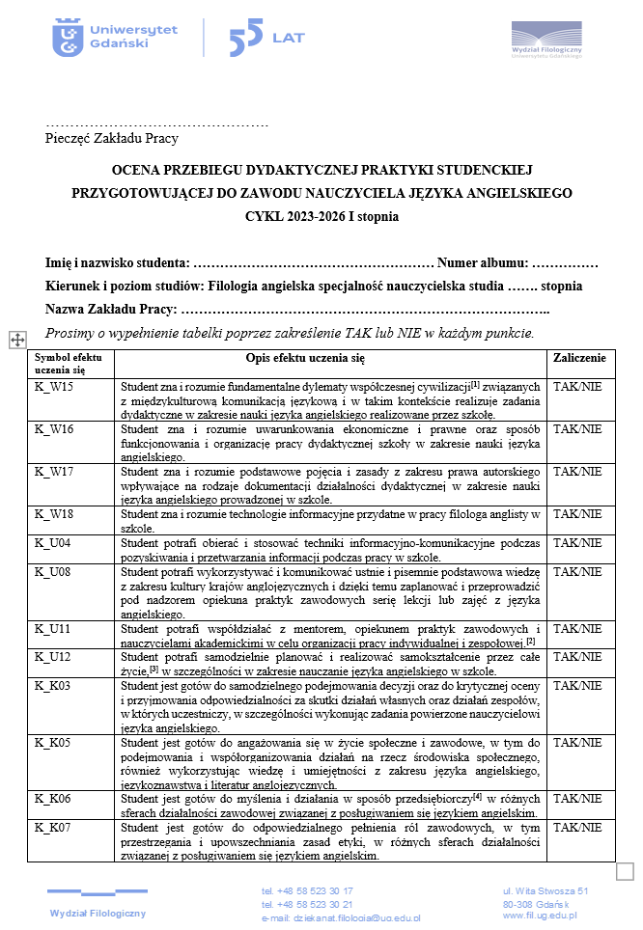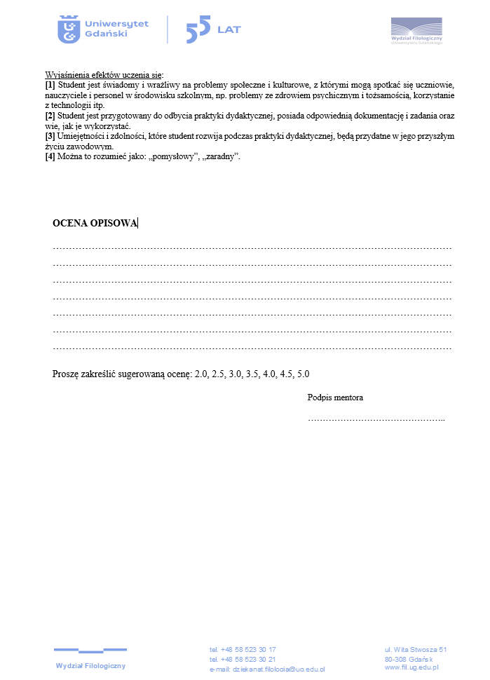
[PLEASE PLACE A COPY OF THIS COMPLETED DOCUMENT IN THIS SPACE IN YOUR PORTFOLIO AND HAND IN THE ORIGINAL TO THE ACADEMIC DIRECTOR OF THE PRACTICES].

3. A completed student practice diary (Dzienniczek praktyki zawodowych) for this module of your practice:
completed by you and signed by your mentors

The up-to-date version of the student practice diary will be sent to you via your group email. It has the following title:

DZIENNIK PRAKTYK ZAWODOWYCH

It looks similar to this:
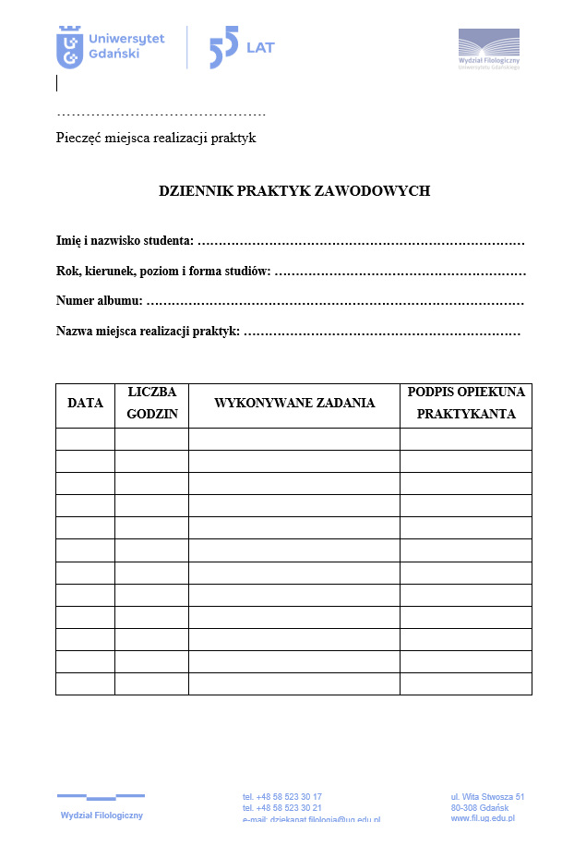
[PLEASE PLACE A COPY OF THIS COMPLETED DOCUMENT IN THIS SPACE IN YOUR PORTFOLIO AND HAND IN THE ORIGINAL TO THE ACADEMIC DIRECTOR OF THE PRACTICES].

4. Mentor evaluation records for 6 of your lessons: 2 for middle-primary 4-6; 2 for upper-primary 7-8; 2 for secondary.
(Completed by your mentor by hand or on computer)

The up-to-date version of the mentor evaluation record will be sent to you via your group email. It has the following title:

MENTOR EVALUATION RECORD

It looks similar to this:
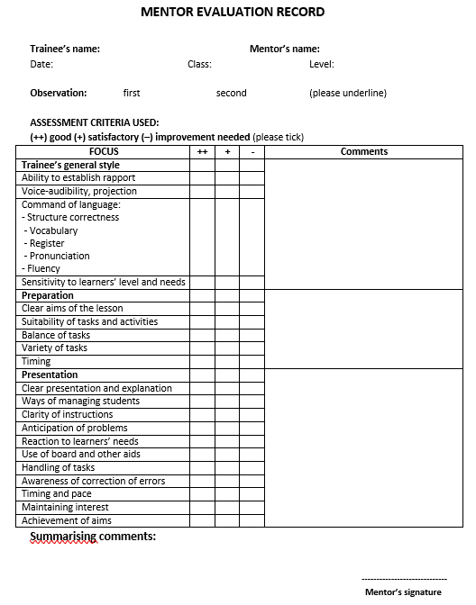
[PLEASE PLACE COPIES OF THIS COMPLETED DOCUMENT IN THIS SPACE IN YOUR PORTFOLIO].

5. Information relating to the syllabuses you were using for each level of the practice – middle-primary 4-6; upper-primary 7-8; secondary:
completed by you and can include contents from a coursebook or syllabus information from the internet (font: Times New Roman 12).

Information relating to syllabus information from the internet can be placed here or copies of the contents pages from the coursebook / coursebooks that are used.

6. DIDACTIC OBSERVATIONS - 45 hours
Primary school - 30 hours (15hours grades 4-6/15hours grades 7-8 – if possible);
Secondary school - 15hours

7. DIDACTIC TEACHING - 75 hours
Primary school - 50 hours (25hours grades 4-6/25hours grades 7-8 – if possible);
Secondary school - 25hours

8. OVERALL REFLECTION ON YOUR DIDACTIC PRACTICE

Please read all three parts carefully before you start this module.

6. In the portfolio include examples of 6 completed observation tasks:
2 for middle-primary 4-6; 2 for upper-primary 7-8; 2 for secondary.
These completed observation tasks should be selected from all of the observations you have chosen to do (font: Times New Roman 12).

DIDACTIC OBSERVATIONS BA 45 hours (Semesters 3, 4 and 5):
- As part of your teaching practice, you are expected to carry out 45 hours of observation – approximately 15 hours for middle-primary (4-6); 15hours for upper-primary (7-8); 15 hours for secondary.

Below, you will find 18 tasks that will help you to do this.

- Please try to carry out the tasks in the order that they are given and write up your ‘findings’ as soon after the observation as possible.
- Use one task for one lesson observed so that you gain a clear idea of the issues being dealt with.
- You may use the tasks more than once.
- For some of the tasks you may be asked to observe two or more, different lessons using the same task.
- You may also devise your own task(s) if there is an area of the teaching practice you are particularly interested in, and it is not covered in the tasks given below.

Throughout the observations you should work in close consultation with your mentor.

AND REMEMBER being observed is stressful, try not to disturb the lesson in any way. Even if you would do things differently DO NOT frown, shake your head or look disapprovingly. Imagine how you would feel if a visitor did this to you!

18 DIDACTIC OBSERVATION TASKS

The classroom, teachers and learners working together, materials and aids

TASK 1. Use of the classroom – to study the set up of the classroom and how it is used by teacher and learners.
Before starting the observation:
a. On an A4 piece of paper, draw a simple diagram of the classroom and how the furniture is arranged.
During the lesson:
b. Mark on your diagram where the teacher and learners sit and work. Mark their movement in the classroom. On a separate piece of paper make notes about the class and the classroom.
After the lesson, use the data collected to help you answer the following questions:
c. Did the teacher stay in one place in the classroom?
d. Did the learners stay in one place in the classroom?
e. How much of the movement was planned by the teacher?
f. What definite areas can you see in the classroom? What are they used for? Which areas were most commonly used by the teacher / by the learners?
g. For your own teaching, how would you use this classroom?

TASK 2. Rapport (TWO LESSONS) - to see how teachers and learners work together in the classroom.
If possible, observe two different teachers. If not, observe the same teacher in two different classes.
a. What kind of attitude does the teacher have towards the learners? How does the teacher show this?
b. What kind of attitude do the learners have towards the teacher? How do the learners show this?
c. Does the teacher use the learners’ names during the lesson? How do the learners respond to the teacher?
d. Does the teacher call upon different learners from different parts of the classroom to answer questions and give information OR does the teacher call upon a limited number of learners repeatedly?
e. Do the learners willingly get involved in the lesson or do they have to be encouraged by the teacher? How does the teacher encourage learners to become involved in the lesson?
f. From this particular lesson, which ways of the teacher and learners working together would you like to use in your teaching? Why?

TASK 3. Use of L1 (Polish) and L2 (English) in the classroom (OBSERVE TWO DIFFERENT LESSONS) – to see what language is used in the English language classroom.
a. What language does the teacher use during the lesson - L1, L2 or both?
b. Are there any stages of the lesson or activities, where the teacher decides to use L1 or L2 only? What are the reasons for this?
c. What language do the learners use during the lesson - L1, L2 or both?
d. How does the teacher encourage the learners to use L2?
e. From this particular lesson, what ideas for getting learners to use L2 would you like to use in your own teaching? Why?

TASK 4. Learners (OBSERVE LEARNERS FROM TWO DIFFERENT LESSONS) - to study how different learners are involved in the lesson.
Choose four pupils from each lesson and watch them carefully during the whole lesson. Pay special attention to their behavior.
a. Are the learners involved throughout the whole lesson?
b. When are they concentrated and attentive? When are they less concentrated and attentive?
c. Do the learners listen to the teacher and follow the instructions given in all situations?
d. Do the learners use L1 or L2? When do they use L1 and when do they use L2? Why?
e. How do the learners show that they are interested or not so interested?
f. From this particular lesson, what ideas for keeping the learners involved and active would you like to use in your own teaching? Why?

TASK 5. Special needs (OBSERVE TWO DIFFERENT LESSONS) - to see how teachers, learners and learners with special needs work together in the classroom.
a. Are there any pupils with special needs in the class? Who are they?
b. Is there someone in the classroom who is there specifically to help these pupils? How is the help given?
c. Is the classroom arranged in any particular way to cater for pupils with special needs?
d. How is the lesson planned to cater for pupils with special needs?
e. How is the work in this class the same or different to other classes you have observed?
f. From this particular lesson, what ideas for working with learners would you like to use in your own teaching? Why?

TASK 6. The coursebook – to gain an idea of what the coursebook offers and how it is used in the lesson.
Before the observation:
a. Does the teacher use a coursebook? What is its title and who are the authors? What additional materials are offered along with the coursebook (workbook, audio CDs, DVD, flashcards, puppets, etc)? What does the teacher think of the coursebook?
During the observation:
b. How do the learners respond to the coursebook?
c. Does the teacher use the coursebook as it is planned, using each exercise in the order that it appears?
d. Does the teacher supplement the coursebook, using extra exercises and materials?
e. Would you enjoy teaching from this coursebook? Why? Why not?
* If the teacher does not use a coursebook go to question 6.

TASK 7. Additional materials – to discover what other materials the teacher uses apart from the coursebook.
Before the observation:
a. Does the teacher use other materials? Do these include any of the following?
    - teaching resources - anything other than a coursebook produced by a publisher for English teaching,
    - teacher produced - anything the teacher produces herself / himself, and
    - realia and authentic materials - this might include real objects, puppets or materials not published specifically for English teaching.
During the observation:
b. Does the teacher enjoy using the materials? Why do you think this is?
c. Do the learners enjoy using the materials? Why do you think this is?
d. Which of the materials that the teacher uses would like to use in your own teaching? Why?
After the observation and when starting to write up your notes of this observation:
- For the teaching resources write the title of the book, CD, or DVD and the names of the authors*.
- For the teacher produced materials provide a brief description of the materials or a quick drawing if this is easier.
- For realia and authentic materials, provide either a brief description of the materials or a quick drawing, or the title of the book, CD, or DVD and the names of the authors*.
* It is best to gather this information after the lesson.

TASK 8. Using the board (blackboard, whiteboard, interactive whiteboard) – to gain an idea of how the board is used by the teacher and learners.
Important: try to observe a lesson where the teacher is planning to use the board.
Before you start your observation:
a. Take an A4 piece of paper and fold it in half so that you end up with two equal rectangles on one side and two equal rectangles on the other. These rectangles represent the board at different stages of the lesson.
During the observation:
b. Observe the lesson and note down / draw what appears on the board throughout the lesson. Each time the board is wiped clean start a new rectangle.
c. On the same piece of paper, make a note of when the teacher uses the board and when the learners use the board – put a T next to the teacher produced information, and an Ls next to the learner produced information.
At the end of the observation look at the visual record you have made.
d. How does the teacher plan their board work? Are there certain areas of the board used to present particular areas of language?
e. How do the learners use the board? How do the learners feel about coming to the board and using it?
f. From this particular lesson, which ways of using the board would you use in your own teaching? Why?

TASK 9. Use of visuals – to gain an idea of the variety of visuals available and their different uses.
a. What visuals are used by the teacher (flashcards, word cards, pictures, photographs...etc)?
b. How are the visuals used (presentation and practice of language; elicitation of grammar or vocabulary; in a game; as part of storytelling...etc)?
c. Does the teacher enjoy handling the visuals?
d. How do the learners respond to the visuals?
e. What are the advantages of using visuals in language teaching?
f. Which of the visuals you have seen in this lesson would you like to use in your own teaching? Why?

DIFFERENT LESSON TYPES AND ERROR CORRECTION

TASK 10. Activities (and stages) (TWO LESSONS) – to become aware of the different activities used in a lesson and how they might be staged.
a. Write a brief description of each of the activities used in the lesson in the order that they appear. Also note down the timing for each activity.
b. Do the activities relate to one particular language point or a number of different points?
c. Are there connections between the activities (thematic, linguistic)?
d. Are connections between activities made clear to the learners?
e. Does there appear to be a reason for the order in which the activities are used?
f. Does the lesson appear to have a number of definite stages? How would you describe them?
g. How would you organize a lesson so that it flows smoothly (i.e. one activity leads ‘naturally’ into another)?

TASK 11. Dynamics in the classroom (OBSERVE TWO DIFFERENT LESSONS)– to notice the different interaction patterns used by the teacher with the learners.
a. Write a brief description of each activity in the order that it appears in the lesson. Next to this description write the kind of interaction pattern(s) used - IW, PW, GW, CW, LS, OTHER *:
e.g.
1. Grammar Practice – playing a card game | PW; GW
2. Listening – predicting what the listening will be about; listening twice, answering and discussing questions; discussion about answers and the topic...  3. ... | PW; IW; PW; IW; PW; CW
After the lesson, Use the information collected to help you answer the following questions:
b. Did the teacher use some interaction patterns more than others? What were they?
c. Were particular interaction patterns used for particular types of activities? Why do you think this is the case?
d. Did the learners seem to prefer some patterns more than others? Why do you think this is the case?
e. What are the reasons for using different types of interaction patterns throughout a lesson?
* IW – individual work; PW – pair work; GW – group work (small groups of 3-5 learners); CW – class work (e.g. during whole class discussion); LS – lockstep (e.g. a teacher explaining or presenting something to the whole class) OTHER – give a brief description

TASK 12. Grammar (OBSERVE TWO DIFFERENT LESSONS)
- to see how grammar is worked on in the classroom.
a. What grammar does the lesson focus on?
b. What does the teacher choose to focus on when teaching the grammar (meaning and use; context; form; pronunciation; problem areas)?
c. Is the grammar presented in context for its communicative value or is it presented for theoretical analysis and discussion?
d. Do the learners practise the grammar during the lesson? How successful are they?
e. Does the lesson take place in L1 or L2?
f. What would you like to take from this observed lesson to use in your own teaching? Why?

TASK 13. Vocabulary (OBSERVE TWO DIFFERENT LESSONS) - to see how vocabulary is worked on in the classroom.
a. Does the lesson include planned or incidental teaching of vocabulary?
b. How many vocabulary items are presented and practised in the lesson?
c. What does the teacher choose to focus on when teaching the vocabulary (meaning; spelling; part of speech; pronunciation)?
d. Is the vocabulary presented in context for its communicative value or is it presented for theoretical analysis and discussion?
e. Do the learners practise the vocabulary during the lesson? How successful are they?
f. Does the lesson take place in L1 or L2?
g. What would you take from this observed lesson to use in your own teaching? Why?

TASK 14. Skills (OBSERVE TWO DIFFERENT LESSONS)
- to see how skills are worked on in the classroom.
a. What skill or skills are being practised? Where is the material taken from - a coursebook/resource book/authentic materials?
b. What does the teacher do to prepare the learners for the skills’ lesson?
c. Are the learners given any tasks to complete when carrying out the skills’ practice? What are they?
d. Do the learners work together at any point(s) during the skills’ practice? When? What do the learners do?
e. Do the learners use L1 or L2 during the lesson?
f. Are any other skills exploited during the lesson (apart from the one which is the main aim of the lesson)?
g. Is feedback given? How is it given?
h. What would you take from this observed lesson to use in your own teaching? Why?

TASK 15. Special project (OBSERVE A NUMBER OF LESSONS) – to see how projects or activities might be carried out over a longer time frame than one lesson*.
a. What is the theme of the project or the subject that links the activities together?
b. What is the timetable for the project? Give details.
c. How does the teacher prepare for the project? How do the learners prepare for the project?
d. What materials or special equipment are used?
e. What are the results of the project? What are the teacher / learner reactions?
f. What are the benefits from carrying out such a project? Would you carry out such a project yourself?
* Such a project might involve storytelling, drama, arts and crafts, preparations for a celebration, etc.

TASK 16. Instructions & explanations (OBSERVE TWO DIFFERENT LESSONS) – to focus on how instructions and explanations are given.
During the lesson:
a. Note down the instructions / explanations that the teacher gives in the lesson and include them as part of your write-up.
b. Note down learner reactions to the instructions / explanations.
After the lesson:
c. Are the instructions long or short?
d. Do the learners always respond to instructions appropriately?
b. Does the teacher have to repeat or rephrase instructions / explanations to help learners understand more fully?
e. Apart from verbal instructions / explanations, does the teacher use any other ways of giving information (facial expression, gesture, demonstration, visuals, board, etc.)?
f. Which ways of giving instructions and / or explanations from this lesson would you like to use in your own teaching? Why?

TASK 17. Error correction – to study the different ways the teacher corrects learners during the lesson.
a. Are mistakes corrected immediately or is delayed correction used?
b. What techniques are used to correct mistakes (verbal, board, facial expression, gesture, etc.)?
c. Are learners corrected in the same way no matter what they are doing (grammar, listening, reading, speaking, writing), or are different correction techniques used depending on the focus of the lesson?
d. Does the teacher encourage self-correction / peer correction?
e. Does the teacher praise the learners for the language they produce?
f. Which forms of error correction from this lesson would you like to use in your own teaching? Why?

Testing
TASK 18. Test Analysis – to develop an awareness of issues involved in testing.
a. Choose a test appropriate for the learners and their abilities (consult with your mentor if you are in any doubt).
b. Before administering the test analyse it and answer the following questions:
How many parts are there to the test?
What language point(s) are they testing?
Does each part test recognition or productive knowledge?
Which part(s) of the test do you think will be the least difficult for the learners? Why?
Which part(s) of the test do you think will be the most difficult for the learners? Why?
c. After administering and checking the test, provide data on how well the learners performed in the test overall, and in each part of the test.
d. Were your predictions about how the learners would perform correct? Why? Why not?
e. With hindsight, would you change anything about the test?
f. What do the test results tell you about the needs of your learners in future lessons?

7. Examples of 6 lesson plans with self-evaluations for each plan and examples of materials used:
2 for middle-primary 4-6; 2 for upper-primary 7-8; 2 for secondary.

These plans and self-evaluations should be selected from all of the plans and self-evaluations you have done (font: Times New Roman 12).

DIDACTIC TEACHING BA 75 hours
Didactic teaching takes the following form.
- To complete this module, you will need to plan, prepare and teach 75 hours of classes in state schools or their equivalents: Primary school - 50 hours (25 hours grades 4-6/25 hours grades 7-8 – if possible); Secondary school - 25hours.
- For each lesson taught you should complete a plan and prepare materials.
- After each lesson, you should also carry out self-evaluation on the basis of what occurred in the lesson.
Throughout the teaching you should work in close consultation with your mentor.

The plans you prepare and self-evaluations you carry out should use the following format:

LESSON PLAN (format)

School / cycle (circle or underline): middle-primary upper-primary secondary

Date of lesson _______________ Class _______________ Number of learners _______________

Subject of the lesson ____________________________________________________________________________________

Aims of the lesson ______________________________________________________________________________________

______________________________________________________________________________________________________

______________________________________________________________________________________________________

No. | Procedure (incl. stages, tasks & activities, teacher (T) and learner (L) activity) | Mode* | Time | Materials
Mode* = modes of work: PW – pair work; IW – individual work; GW – group work (small groups of 3-5 learners); CW – class work (e.g. during whole class discussion); LS – lockstep (e.g. a teacher explaining or presenting something to the whole class)

Student signature: Mentor signature:

The self-evaluation you carry out can have as a starting point the following questions BUT should aim to go further.
SELF-EVALUATION (format)
1. Did the lesson go according to plan? Give details and say why you think this was the case.
2. What was the greatest success of the lesson? Why?
3. What would you change if you were to run this lesson again? Why?
4. How did you feel during the lesson? How do you believe the learners felt during the lesson? Give reasons for your answers.

8. Reflection
– no less than four A4 sheets of paper written by you (font: Times New Roman 12).

OVERALL REFLECTION ON YOUR DIDACTIC PRACTICE

a) Give your overall impression of your teaching practice.

b) Briefly describe what you found to be the differences between teaching at the following levels:
middle-primary (4-6), upper-primary (7,8) and secondary

c) From the observations you carried out and the lessons you taught:
i) describe the knowledge / skills you have gained from your teaching practice. Give specific examples.
ii) describe the things you view to be the successes of your teaching practice. Give specific examples.
iii) say what you feel you still need to work on as a teacher. Give specific examples.
iv) say what you would do differently if you could do your teaching practice over again. Give specific
examples.

d) other comments relating to this part of your practice that you would like to share.

